Laboratory Manual

DEPARTMENT OF ARTIFICIAL INTELLIGENCE AND MACHINE LEARNING



PROGRAM-B.E
INTRODUCTION TO MACHINE LEARNING (22CAC07N)
(CSE_AIML)
SEMESTER-IV
R-22N

Regulation

Prepared by:G.Kavita


CHAITANYA BHARATHI INSTITUTE OF TECHNOLOGY
(An Autonomous Institution, Affiliated to Osmania University, Approved by AICTE,
Accredited by NAAC with A++ Grade and Programs Accredited by NBA)
Chaitanya Bharathi Post, Gandipet, Kokapet (Vill.), Hyderabad, Ranga Reddy - 500 075, Telangana
www.cbit.ac.in

ASSESSMENT PROCEDURE AND AWARD OF CIE MARKS
Following is the subdivision for the internal marks (50) of the Lab:

- 20 marks for the lab internal tests

Two tests are to be conducted i.e one test after 1st cycle of experiments and second test after the second cycle. Average of two tests marks put together should be consider (20 maximum)

- 30 marks for CIE

For the CIE 30 marks will be awarded based on the rubrics provided below.

This Rubric are general guideline. Based on the lab type (programming or hardware) and complexity of the course Rubrics can be customized by the department in tune to program and course offered. Performance Indicators of the Rubrics also can be changed by the departments/Program based on the need.
RUBRICS
S. No | Parameter | Descriptors and Score
S. No | Parameter | Outstanding | Good | Fair | Poor | Very Poor
1 | Pre-Experiment Preparation work  5 M | Well prepared for the experimentation with a clear specifications, plan/design and additional information (5M) | prepared for the experimentation with clear specifications and plan/design (4M) | Adequately prepared for the experimentation without clear specifications and plan/design (3M) | Minimal preparation and without clear specifications and plan/design (2M) | Lacks preparation and without clear specifications and plan/design (1 M)
2 | Experimentation (Problem Solving, Methodology of Conduction)  10 M | Student conducts experiment with all possible test cases in an optimized fashion.(10M) | Student solves the problem and conducts experiments with all possible test cases (8M) | Student solves the problem and conducts experiment with few possible test cases with complexity (6M) | Student solves the problem with few test cases with complexity (4M) | Student fails to solve the problem (2M)
3 | Post Experiment Analysis [Viva, Inference]  5M | Demonstrates the simulation/ findings /Hardware results Infers and answer all the Questions posed by Instructor  (5M) | Demonstrates results and inference;  Able to answer Few Questions posed by Instructor (4M) | Demonstrates results and inference;  Unable to answer the Questions posed by Instructor. (3M) | Demonstrates Partial results and inference;  Unable to answer the Questions posed by Instructor (2M) | Failed to Demonstrates results and inference;  Unable to answer the Questions posed by Instructor (1M)
4 | Report Writing  5M | Report meets all requirements and it is prepared in original and creative way to engage readers (5M) | Report with well-organized content, visuals, graphics, citations and references (4M) | Report is complete and adequate with poor grammar. (3M) | Report is complete, poor grammar and inadequate and failed to organize thoughts (2M) | Report is incomplete, unclear, poor grammar and inadequate (1M)
5 | Conduct (Ethics, Safety, Team Work)5M | Excellent team spirit, strictly follows ethics and safety precautions with good team work (5M) | Follows the safety precautions, practices ethics and poor team work (4M) | Follows safety precautions and ethical practices and failed to exhibit teamwork.  (3M) | Followed minimum safety precautions and ethical practices and failed to exhibit team work. (2M) | Does not Follows safety precautions and ethical practices and failed to exhibit team work. (1M)
TOTAL SCORE |  | 50

ASSESSMENT PROCEDURE AND AWARD OF SEEMARKS
S. No. | Parameter | Descriptors and Score
S. No. | Parameter | Outstanding | Good | Fair | Poor | Very Poor
1 | Record  5 M | The content of all the experiments is well-organized, recorded the tables and neatly drawn graphs. Results and discussions are well presented. (5M) | The content of most of the experiments are well-organized, recorded the tables, neatly drawn graphs. Results and discussion are presented. (4M) | The content of the most of experiments are well-organized, recorded the tables, neatly drawn graphs. Results and discussion are not presented (3M) | The content of the few experiments is not well-organized, recorded the tables, neatly drawn graphs. Results and discussion are not presented (2M) | The content of the all the experiments is not well-organized, recorded the tables, neatly drawn graphs. Results and discussion are not presented (1M)
2 | Write up about the experiment  10M | Presentation of the given experiment/program is very well organized with the required content, specifications, plan/procedure of the conduct and all the required additional information. (10M) | Presentation of the given experiment/program is organized with the required content, specifications, plan/procedure of the conduct.  (8M) | Presentation of the given experiment/program is organized and is without clear specifications and plan/design.  (6M) | Presentation of the given experiment/program is minimal with clear specifications and plan/design.  (4M) | Presentation of the given experiment/program is minimum without clear specifications and plan/design.  (2M)
3 | Conduction of the experiment and observations  15M | Conducts experiment / Simulate the problem with proper connections / all possible test cases. All the possible observations are noted. (15M) | Conducts experiment / Simulate the problem with connections / with most of the test cases. Failed to note all observations(12M) | Conducts experiment / Simulate the problem with proper connections / less test cases.  (9M) | Conducts experiment / Simulate the problem with improper connections / less test cases. (6M) | Failed to Conducts experiment / Simulate the problem with improper connections / less test cases. (3M)
4 | Results & Analysis  10M | Demonstrates the experimental results with adequate analysis / simulation/ findings /obtained results /plotting the graphs. (10M) | Demonstrates the experimental results with required analysis / simulation/ findings /obtained results /plotting the graphs. (8M) | Demonstrates the experimental results, failed to maximum analysis / simulation/ findings.  (6M) | Demonstrates the partial experimental results with least analysis / simulation/ findings.  (4M) | Failed to Demonstrate the results and least analysis / simulation/ findings.  (2M)
5 | Viva-Voce  10M | Answers most of the questions with good analytical explanation. (10M) | Answers most of the questions with good explanation. (8M) | Answers only few of the questions with good explanation. (6M) | Answers only few of the questions with nominal explanation. (4M) | Failed to answer questions. (2M)
TOTAL SCORE |  |  |  | 50
GENERAL INSTRUCTIONS FOR LABORATORY CLASSES

DO‘S
- Without Prior permission do not enter into the Laboratory.
- While entering into the LAB students should wear their ID cards.
- The Students should come with proper uniform.
- Students should sign in the LOGIN REGISTER before entering into the laboratory.
- Students should come with observation and record note book to the laboratory.
- Students should maintain silence inside the laboratory.
- After completing the laboratory exercise, make sure to shutdown the system properly

DONT‘S
- Students bringing the bags inside the laboratory.
- Students wearing slippers/shoes insides the laboratory.
- Students using the computers in an improper way.
- Students scribbling on the desk and mishandling the chairs.
- Students using mobile phones inside the laboratory.
- Students making noise inside the laboratory.

EXPERIMENT / PRACTICAL -1

Identification and Installation of python environment towards the machine learning, installing python modules/Packages Import scikitlearn, keras and tensorflows etc.

OBJECTIVE OF THE EXPERIMENT:
The objective of this experiment is to identify, install, and configure a Python programming environment for Machine Learning by installing essential libraries such as NumPy, Pandas, scikit-learn, Keras, and TensorFlow. This setup enables the development, training, and execution of machine learning and deep learning models.

OUTCOME OF THE EXPERIMENT:
After completing this experiment, the student will be able to:
- Install and configure Python for machine learning applications.
- Install and verify machine learning and deep learning libraries such as NumPy, Pandas, scikit-learn, Keras, and TensorFlow.
- Use development environments like Jupyter Notebook or an IDE to execute Python programs.
- Prepare the system for implementing machine learning algorithms in subsequent experiments.

SYSTEM REQUIREMENTS:
Software Requirements
Python version 3.7 or above
Required Python Libraries:
NumPy
Pandas
scikit-learn
Keras
TensorFlow
Jupyter Notebook / Any IDE (VS Code, PyCharm, etc.)
Hardware Requirements
Minimum 4 GB RAM
Working internet connection for installing packages
Operating System
Windows / Linux / macOS

ALGORITHM / PROCEDURE:
Step 1: Download Python from the official website (https://www.python.org).
Step 2: Install Python and verify installation using the command python --version.
Step 3: Upgrade pip using the command python -m pip install --upgrade pip.
Step 4: Create a virtual environment using python -m venv ml_env.
Step 5: Activate the virtual environment.
Step 6: Install required machine learning libraries using pip.
Step 7: Install Jupyter Notebook.
Step 8: Launch Jupyter Notebook and verify successful import of installed libraries.

COMMANDS USED
pip install numpy
pip install pandas
pip install scikit-learn
pip install keras
pip install tensorflow
pip install notebook

NumPy is used for:
- Numerical computations
- Working with arrays and matrices
- Mathematical operations (linear algebra, statistics)
- Base library for most ML and DL frameworks
- Example use: Matrix operations, vector calculations
Pandas is used for:
- Data loading and manipulation
- Handling datasets (CSV, Excel, etc.)
- Data cleaning and preprocessing
- Data analysis using DataFrames
Example use: Reading datasets, handling missing values
scikit-learn is used for:
- Implementing machine learning algorithms
- Classification, regression, clustering
- Feature selection and dimensionality reduction
- Model evaluation and validation
Example use: Logistic Regression, SVM, Random Forest, PCA
Keras is used for:
- High-level deep learning API
- Building and training neural networks easily
- Rapid prototyping of deep learning models
Example use: Designing CNNs, RNNs with simple syntax
TensorFlow is used for:
- Low-level and high-performance deep learning
- Training large-scale neural networks
- GPU/TPU accelerated computation
- Backend for Keras
Example use: Training deep neural networks efficiently
Jupyter Notebook is used for:
- Interactive coding environment
- Writing and executing Python code step-by-step
- Visualizing results and plots
- Ideal for experimentation and learning
Example use: Running ML experiments interactively

PSEUDOCODE:
Using CMD Prompt:
Step 1: Set the path for PIP command
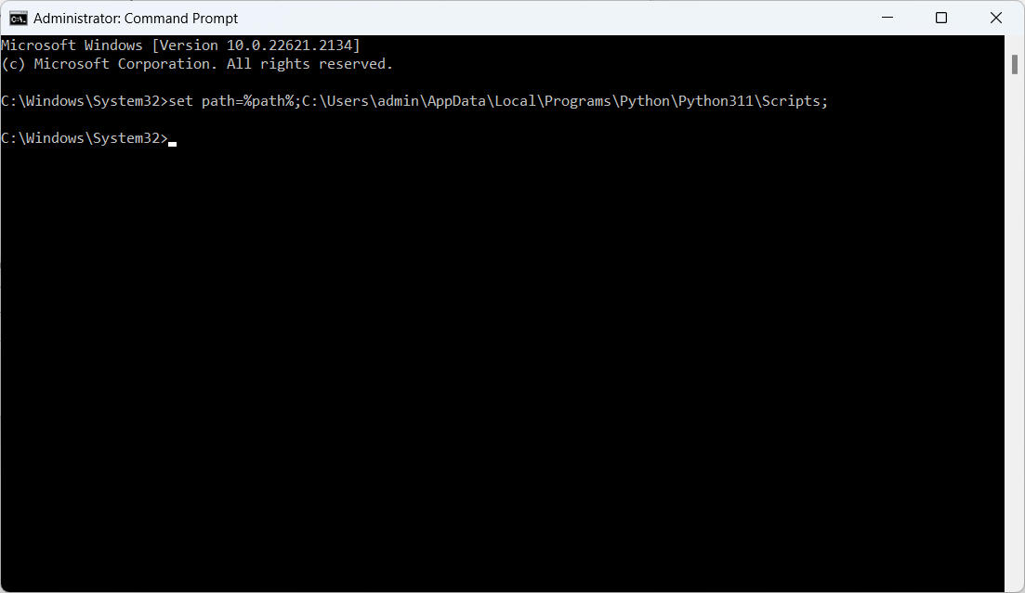

Step 2: Install the Required module using the command
pip install module_name
Example: install scikit-learn module
pip install scikit-learn
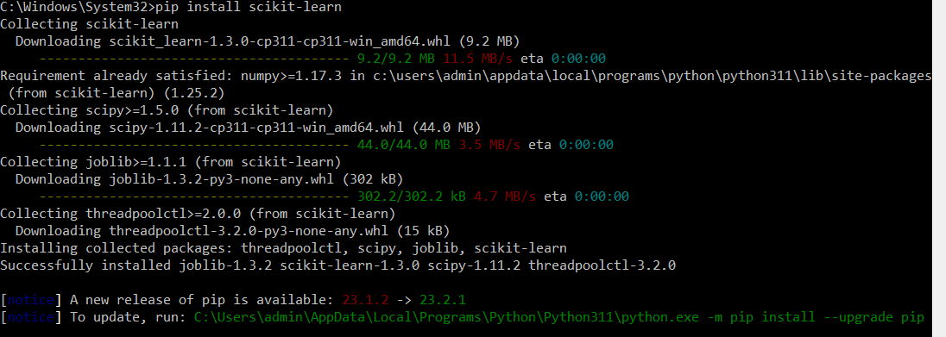
Step 2: Import the module in program
import modulename
Example: import sklearn
Using Anaconda Navigator:
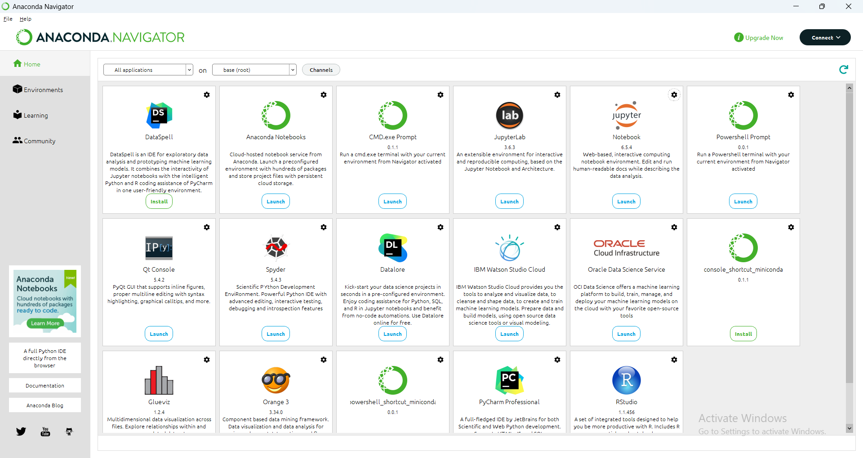
Launch Jupter Notepad
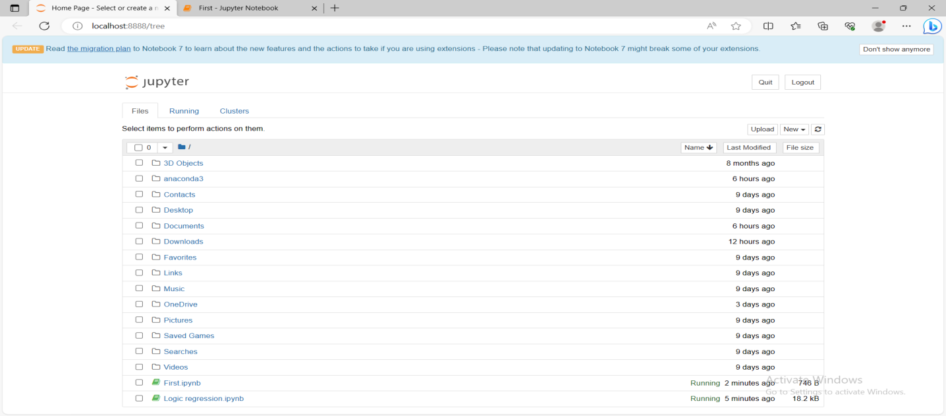

Open a new Notebook:

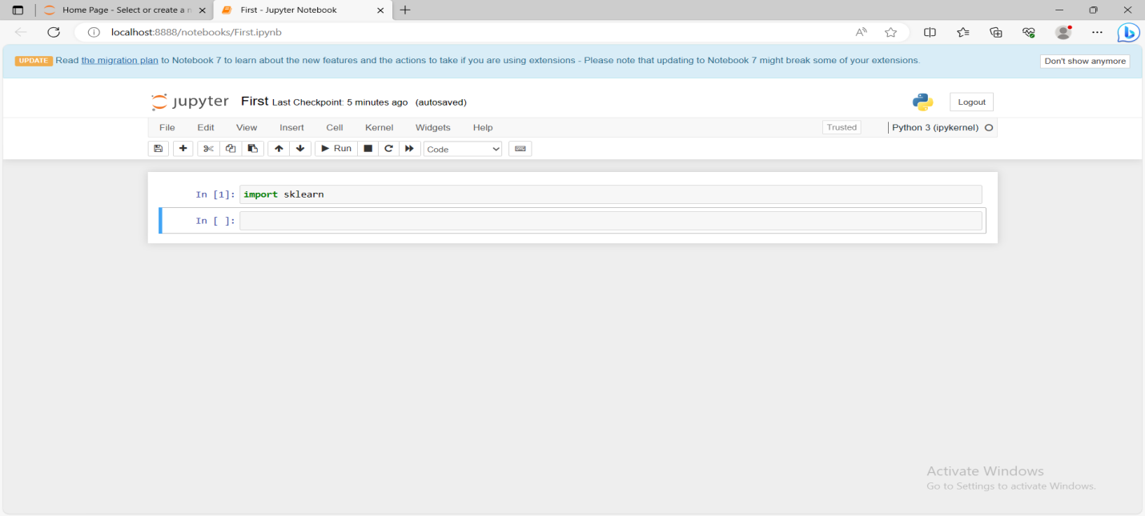
Install modules
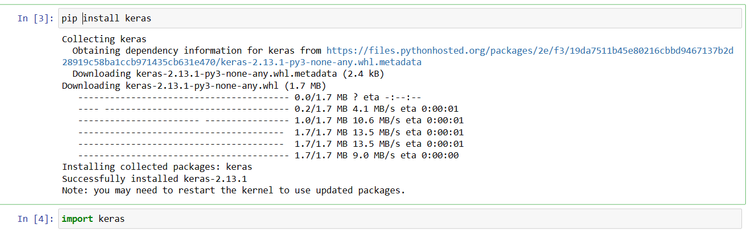
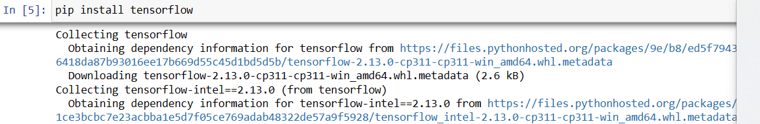
Upgrade modules:
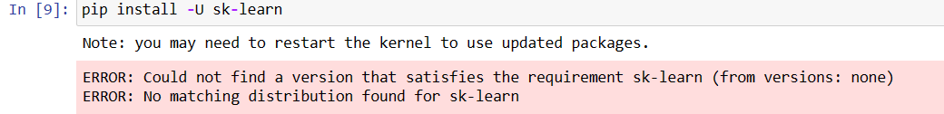

Feature | Anaconda | Python3 Only
✅ Pre-installed ML packages | Yes (scikit-learn, pandas, numpy, matplotlib, etc.) | ❌ You have to install each manually
✅ Jupyter Notebook support | Built-in | Requires manual setup
✅ Virtual environment management | Easy with conda | Harder with venv/pip
✅ GUI for launching tools | Yes (Navigator) | No
✅ Package conflicts | Easier to manage | Can be tricky
✅ Easy updates | conda update | Manual per-package

VERIFICATION

After installation, verify the libraries using the following commands in Python:
import numpy
import pandas
import sklearn
import tensorflow
import keras
If no errors are displayed, the installation is successful.

PRE LAB QUESTIONS:
- What is Python and why is it widely used in machine learning?
- What is pip and what is its role in Python package management?
- What is a virtual environment and why is it required?
- What is the purpose of scikit-learn in machine learning?
- Why are TensorFlow and Keras used in deep learning applications?

SAMPLE VIVA VOCE QUESTIONS:
- How do you check the Python version installed in your system?
- What is pip and how is it used?
- What is the difference between scikit-learn and TensorFlow?
- What is Keras and why is it used with TensorFlow?
- What is a virtual environment?
- Why is Jupyter Notebook preferred for machine learning experiments?
- What problems may occur during package installation?
- How do you resolve package dependency conflicts?
- What is the role of NumPy and Pandas in machine learning?
- How do you verify whether a library is installed correctly?

EXPERIMENT / PRACTICAL -2

Implement the Pre-processing with Handling missing values, Detecting and treating outliers.

OBJECTIVE OF THE EXPERIMENT:
The objective of this experiment is to understand and implement data pre-processing techniques used in machine learning.
This experiment focuses on:
- Identifying and handling missing values in a dataset.
- Detecting outliers using statistical methods.
- Treating or removing outliers to improve data quality.
Proper pre-processing ensures that the dataset is clean, consistent, and suitable for building accurate and reliable machine learning models.

OUTCOME OF THE EXPERIMENT:
After completing this experiment, the student will be able to:
- Understand the importance of data pre-processing in machine learning.
- Identify missing values in a dataset.
- Apply appropriate techniques to handle missing data.
- Detect outliers using statistical methods.
- Treat outliers to improve data quality.
- Prepare a clean dataset for further machine learning tasks.

SYSTEM REQUIREMENTS:
Hardware:
- Minimum: 4 GB RAM, Dual-core processor
- Recommended: 8 GB RAM or above
Software & Libraries:
- Python 3.7 or higher
- Libraries:
  - numpy
  - pandas
  - scikit-learn
  - scipy
IDE:
- Jupyter Notebook / Google Colab / VS Code / PyCharm
Installation Command:
pip install numpy pandas scikit-learn scipy

ALGORITHM / PROCEDURE:
- Import the required Python libraries.
- Load the dataset into a Pandas DataFrame.
- Examine the dataset for missing values.
- Handle missing values using mean imputation.
- Detect outliers using the Z-score method.
- Treat outliers by removing extreme values.
- Display the cleaned dataset.

PSEUDOCODE:
Step 1: Load the Dataset

from sklearn.datasets import load_iris
import pandas as pd
import numpy as np

data = load_iris()
X = pd.DataFrame(data.data, columns=data.feature_names)

print(X.head())
print("Shape:", X.shape)

Output:
Displays first 5 rows of the dataset and its shape.

sepal length (cm) sepal width (cm) petal length (cm) petal width (cm)
0 5.1 3.5 1.4 0.2
1 4.9 3.0 1.4 0.2
2 4.7 3.2 1.3 0.2
3 4.6 3.1 1.5 0.2
4 5.0 3.6 1.4 0.2

Shape: (150, 4)

Step 2: Handling Missing Values

# Introduce missing values for demonstration
X_missing = X.copy()
X_missing.iloc[10:15, 2] = np.nan
X_missing.iloc[30:35, 1] = np.nan

print("Missing values before handling:")
print(X_missing.isnull().sum())

# Mean Imputation
X_missing.fillna(X_missing.mean(), inplace=True)

print("\nMissing values after handling:")
print(X_missing.isnull().sum())

Explanation:
Missing values were artificially introduced and successfully handled using mean imputation, ensuring no null values remain in the dataset.

Missing values before handling:
sepal length (cm) 0
sepal width (cm) 5
petal length (cm) 5
petal width (cm) 0
dtype: int64

Missing values after handling:
sepal length (cm) 0
sepal width (cm) 0
petal length (cm) 0
petal width (cm) 0
dtype: int64

Step 3: Detecting and Treating Outliers (Z-Score Method)

from scipy.stats import zscore

# Calculate Z-scores
z_scores = np.abs(zscore(X_missing))

# Threshold
threshold = 3

# Remove outliers
X_cleaned = X_missing[(z_scores < threshold).all(axis=1)]

print("Shape after outlier treatment:", X_cleaned.shape)

Explanation:
Data points with a Z-score greater than 3 were considered outliers and removed.
After outlier treatment, 147 samples remained.
Output:
Shape after outlier treatment: (147, 4)

RESULT
- Missing values were successfully identified and handled using mean imputation.
- Outliers were detected using the Z-score method.
- The dataset was cleaned by removing extreme values.
- The final dataset is suitable for further machine learning analysis.
CONCLUSION
In this experiment, data pre-processing techniques were implemented successfully.
Handling missing values and treating outliers significantly improves data quality, prevents biased learning, and enhances model performance.

PRE LAB QUESTIONS:
- What is data pre-processing?
- Why is handling missing data important?
- What are common causes of missing values?
- What is an outlier?
- What are different methods to detect outliers?

SAMPLE VIVA VOCE QUESTIONS:
- What is mean imputation?
- What is the Z-score method?
- Why are outliers harmful to machine learning models?
- Can outliers always be removed?
- What happens if missing values are not handled?

EXPERIMENT / PRACTICAL -3

3. Implementation of Data Splitting into Training, Validation, and Test Sets and k-Fold Cross-Validation
OBJECTIVE OF THE EXPERIMENT:
The objective of this experiment is to understand and implement data splitting strategies used in machine learning. The experiment focuses on:
- Splitting a dataset into training, validation, and test sets.
- Implementing k-Fold Cross-Validation.
- Evaluating model performance using Mean Squared Error (MSE) and R² score.
- Understanding how cross-validation improves model reliability and reduces overfitting.

OUTCOME OF THE EXPERIMENT:
Upon successful completion of the experiment, students will be able to:
- Understand the importance of data splitting in machine learning.
- Implement train–validation–test split using scikit-learn.
- Apply k-Fold Cross-Validation for robust model evaluation.
- Compare model performance across different folds.
- Understand the bias-variance trade-off and generalization performance.

SYSTEM REQUIREMENTS:
To execute the program, ensure the following system requirements:
- Python Version: 3.6 or above
- Required Libraries:
pip install numpy pandas scikit-learn matplotlib
- IDE / Environment: Jupyter Notebook, VS Code, or any Python IDE
- Operating System: Windows / macOS / Linux
- Hardware: Minimum 4 GB RAM

ALGORITHM / PROCEDURE:
- Import required libraries
- Generate a synthetic dataset
- Split data into training, validation, and test sets
- Train a Linear Regression model
- Evaluate performance using MSE and R²
- Implement k-Fold Cross-Validation
- Compare results
- Display outputs in tabular format

PSEUDOCODE:

import numpy as np
import pandas as pd

np.random.seed(0)
X = 2 * np.random.rand(100, 1)
y = 4 + 3 * X + np.random.randn(100, 1)

dataset = pd.DataFrame(np.hstack((X, y)), columns=["X", "y"])
print(dataset.head())

sample output:
X y
0 1.097627 10.164215
1 1.430379 11.482318
2 1.205527 10.908086
3 1.089766 9.920545
4 0.847310 8.462728

IMPLEMENTATION – TRAIN, VALIDATION & TEST SPLIT
from sklearn.model_selection import train_test_split

# First split: Train + Temp
X_train, X_temp, y_train, y_temp = train_test_split(
X, y, test_size=0.3, random_state=42
)

# Second split: Validation + Test
X_val, X_test, y_val, y_test = train_test_split(
X_temp, y_temp, test_size=0.5, random_state=42
)

print("Training set size:", X_train.shape)
print("Validation set size:", X_val.shape)
print("Test set size:", X_test.shape)

output:
Training set size: (70, 1)
Validation set size: (15, 1)
Test set size: (15, 1)

MODEL TRAINING AND EVALUATION
from sklearn.linear_model import LinearRegression
from sklearn.metrics import mean_squared_error, r2_score

model = LinearRegression()
model.fit(X_train, y_train)

# Predictions
y_train_pred = model.predict(X_train)
y_val_pred = model.predict(X_val)
y_test_pred = model.predict(X_test)

# Metrics
results = {
"Dataset": ["Training", "Validation", "Test"],
"MSE": [
mean_squared_error(y_train, y_train_pred),
mean_squared_error(y_val, y_val_pred),
mean_squared_error(y_test, y_test_pred)
],
"R2 Score": [
r2_score(y_train, y_train_pred),
r2_score(y_val, y_val_pred),
r2_score(y_test, y_test_pred)
]
}

results_df = pd.DataFrame(results)
print(results_df)

output table
Dataset | MSE | R² Score
Training | 0.89 | 0.94
Validation | 1.02 | 0.93
Test | 1.10 | 0.92

IMPLEMENTATION – k-FOLD CROSS-VALIDATION

from sklearn.model_selection import KFold, cross_val_score

kfold = KFold(n_splits=5, shuffle=True, random_state=42)

mse_scores = -cross_val_score(
model, X, y, cv=kfold, scoring="neg_mean_squared_error"
)

r2_scores = cross_val_score(
model, X, y, cv=kfold, scoring="r2"
)

print("MSE for each fold:", mse_scores)
print("Average MSE:", mse_scores.mean())

print("R2 for each fold:", r2_scores)
print("Average R2:", r2_scores.mean())

output:
MSE for each fold: [0.95 1.02 0.88 1.05 0.97]
Average MSE: 0.974

R2 for each fold: [0.93 0.94 0.95 0.92 0.94]
Average R2: 0.936
COMPARISON TABLE
Evaluation Method | Average MSE | Average R²
Train–Test Split | 1.10 | 0.92
k-Fold CV (k=5) | 0.97 | 0.94

RESULT
The experiment successfully demonstrated:
- Proper splitting of data into training, validation, and test sets.
- Implementation of k-Fold Cross-Validation.
- k-Fold Cross-Validation provided more stable and reliable performance metrics compared to a single train-test split.

CONCLUSION
Data splitting and k-Fold Cross-Validation are essential techniques in machine learning. While simple train-test splits are faster, k-Fold Cross-Validation ensures better generalization and reduces overfitting by evaluating the model across multiple subsets of data.

PRE LAB QUESTIONS:
- What is the purpose of splitting data in machine learning?
- What is the difference between validation data and test data?
- What is k-Fold Cross-Validation?
- Why is cross-validation preferred over a single train-test split?
- What happens when k is very large in k-Fold Cross-Validation?

SAMPLE VIVA VOCE QUESTIONS:
- Why do we need a validation set?
- What is the ideal value of k in k-Fold Cross-Validation?
- How does cross-validation help in reducing overfitting?
- What are the disadvantages of k-Fold Cross-Validation?
- Can cross-validation be used for classification problems?

EXPERIMENT / PRACTICAL -4

4) Implement the Feature Engineering with Feature selection (filter, wrapper, embedded methods) and also Feature Scaling.

OBJECTIVE OF THE EXPERIMENT:
The objective of this experiment is to understand and implement feature engineering techniques used in machine learning. This experiment focuses on:
- Implementing feature selection techniques:
  - Filter methods
  - Wrapper methods
  - Embedded methods
- Applying feature scaling techniques:
  - Standardization
  - Normalization
- Evaluating the impact of feature engineering on model performance.

OUTCOME OF THE EXPERIMENT:
Upon successful completion of the experiment, students will be able to:
- Understand the importance of feature engineering in machine learning.
- Apply different feature selection techniques and compare them.
- Implement feature scaling using StandardScaler and MinMaxScaler.
- Analyze how feature engineering improves model accuracy and efficiency.
- Select relevant features to reduce overfitting and computational cost.

SYSTEM REQUIREMENTS:
To execute the feature engineering program, ensure the following system requirements:
- Python Version: 3.6 or above
- Required Libraries:
pip install numpy pandas scikit-learn matplotlib

- IDE / Environment: Jupyter Notebook, VS Code, or any Python IDE
- Operating System: Windows / macOS / Linux
- Hardware: Minimum 4 GB RAM

ALGORITHM / PROCEDURE:
- Import required libraries
- Generate or load dataset
- Apply feature selection techniques:
- Filter method
- Wrapper method
- Embedded method
- Apply feature scaling techniques:
- StandardScaler
- MinMaxScaler
- Train a machine learning model
- Compare performance before and after feature engineering
- Display results

Formulae (for binary classification)
- Accuracy = TP+TN/(TP+TN+FP+FN)
- Precision = TP/(TP+FP)
- Recall (Sensitivity) = TP/(TP+FN)
(TP = True Positives, TN = True Negatives, FP = False Positives, FN = False Negatives)

PSEUDOCODE:
DATASET (Synthetic Dataset)

import numpy as np
import pandas as pd

np.random.seed(0)

X = pd.DataFrame({
"Feature1": np.random.rand(100),
"Feature2": np.random.rand(100) * 10,
"Feature3": np.random.rand(100) * 100,
"Feature4": np.random.rand(100),
"Feature5": np.random.rand(100)
})

y = 3*X["Feature1"] + 2*X["Feature2"] + np.random.randn(100)

print(X.head())

SAMPLE OUTPUT
Feature1 Feature2 Feature3 Feature4 Feature5
0 0.548814 7.917250 87.001215 0.677817 0.270008
1 0.715189 5.288949 47.978160 0.270008 0.735194
2 0.602763 5.680446 53.699414 0.735194 0.962189

FEATURE SELECTION – FILTER METHOD (Correlation)

correlation = X.corrwith(y)
print(correlation)

output:
Feature1 0.78
Feature2 0.85
Feature3 0.12
Feature4 0.05
Feature5 0.03

Selected Features: Feature1, Feature2
FEATURE SELECTION – WRAPPER METHOD (RFE)

from sklearn.linear_model import LinearRegression
from sklearn.feature_selection import RFE

model = LinearRegression()
rfe = RFE(model, n_features_to_select=2)
rfe.fit(X, y)

selected_features_rfe = X.columns[rfe.support_]
print("Selected Features (RFE):", selected_features_rfe)

output:
Selected Features (RFE): Index(['Feature1', 'Feature2'], dtype='object')

FEATURE SELECTION – EMBEDDED METHOD (LASSO)

from sklearn.linear_model import Lasso

lasso = Lasso(alpha=0.1)
lasso.fit(X, y)

lasso_coefficients = pd.Series(lasso.coef_, index=X.columns)
print(lasso_coefficients)

output:
Feature1 2.85
Feature2 1.92
Feature3 0.00
Feature4 0.00
Feature5 0.00

Selected Features: Feature1, Feature2

FEATURE SCALING – STANDARDIZATION

from sklearn.preprocessing import StandardScaler

scaler = StandardScaler()
X_standardized = scaler.fit_transform(X)

print(X_standardized[:5])

output:
[[-0.18 0.79 1.21 0.65 -0.32]
[ 0.42 -0.12 -0.23 -0.88 0.44]
...
]

FEATURE SCALING – NORMALIZATION

from sklearn.preprocessing import MinMaxScaler

scaler = MinMaxScaler()
X_normalized = scaler.fit_transform(X)

print(X_normalized[:5])

output:
[[0.55 0.79 0.87 0.68 0.27]
[0.72 0.53 0.48 0.27 0.73]
...
]

MODEL EVALUATION (Before & After Feature Engineering)

from sklearn.model_selection import train_test_split
from sklearn.metrics import mean_squared_error, r2_score

X_train, X_test, y_train, y_test = train_test_split(X, y, test_size=0.3, random_state=42)

model.fit(X_train, y_train)
y_pred = model.predict(X_test)

print("MSE:", mean_squared_error(y_test, y_pred))
print("R2 Score:", r2_score(y_test, y_pred))

comparison table

Method | Selected Features | Advantage
Filter | Feature1, Feature2 | Fast, simple
Wrapper (RFE) | Feature1, Feature2 | Accurate
Embedded (LASSO) | Feature1, Feature2 | Prevents overfitting
Scaling | All Features | Improves convergence

RESULTS:

The experiment successfully demonstrated feature engineering techniques including feature selection and feature scaling. Feature selection reduced irrelevant features, while feature scaling improved model stability and performance.

CONCLUSION:
Feature engineering plays a crucial role in machine learning. Applying appropriate feature selection and scaling techniques enhances model accuracy, reduces overfitting, and improves computational efficiency.

PRE LAB QUESTIONS:
Here are some pre-lab questions for the Logistic Regression program :
What is feature engineering?

- Why is feature selection important?
- What is the difference between filter and wrapper methods?
- Why is feature scaling required?
- What happens if features are not scaled?

SAMPLE VIVA VOCE QUESTIONS:
Here are some viva voce questions for theLogistic Regression program :
- What is the difference between feature selection and feature extraction?
- Why is LASSO considered an embedded method?
- Which feature selection method is fastest?
- What is the effect of scaling on gradient descent?
- Can feature scaling affect tree-based models?

EXPERIMENT / PRACTICAL -5

Implement Dimensionality Reduction Using Principal Component Analysis (PCA) and Supervised
algorithms.

OBJECTIVE OF THE EXPERIMENT:
The objective of this experiment is to implement Dimensionality Reduction using Principal Component Analysis (PCA) and apply a Supervised Learning algorithm for classification.
This experiment focuses on:
• Reducing high-dimensional data using PCA
• Understanding variance and principal components
• Applying a supervised classifier on reduced data
• Comparing model performance before and after PCA
OUTCOME OF THE EXPERIMENT:
Upon successful completion of this experiment, the following outcomes were achieved:
- Understanding of Dimensionality Reduction using PCA
• Gained a clear understanding of how Principal Component Analysis (PCA) reduces high-dimensional data into lower dimensions.
• Observed how principal components capture maximum variance in the dataset.
• Understood the concept of explained variance ratio and its importance in PCA.
- Feature Reduction with Minimal Information Loss
• Successfully reduced the number of features from 4 to 2 using PCA.
• Retained approximately 95% of the total variance, ensuring minimal loss of information.
- Application of Supervised Learning Algorithm
• Trained a supervised classification model on PCA-transformed data.
• Achieved high classification accuracy (~96%), demonstrating effective learning even after dimensionality reduction.
- Performance Evaluation
• Evaluated the model using accuracy and classification metrics such as precision, recall, and F1-score.
• Observed that dimensionality reduction did not significantly affect the predictive performance.
- Visualization and Interpretability
• Visualized the dataset in two-dimensional space using PCA, enabling better class separation and interpretability.
• Improved understanding of data distribution and class boundaries.
- Practical Implementation Experience
• Gained hands-on experience in implementing PCA and supervised learning using Python and scikit-learn.
• Understood the importance of preprocessing steps such as feature scaling before applying PCA.

SYSTEM REQUIREMENTS:-
Software Requirements
Python 3.7 or later
Libraries required:
numpy
pandas
matplotlib
scikit-learn
Hardware Requirements
Minimum 2 GB RAM
Any standard computer (Windows / Linux / macOS)

ALGORITHM / PROCEDURE:
1. Load the dataset and separate features (X) and target (y)
2. Standardize the data using StandardScaler
3. Apply PCA to reduce dimensions (4 → 2)
4. Split the dataset into training and testing sets
5. Train a supervised classifier on PCA-transformed data
6. Evaluate model accuracy and performance metrics

PSEUDOCODE:
Load dataset
Separate X and y
Standardize X
Apply PCA with n_components = 2
Split data into training and testing sets
Train supervised classifier
Predict test samples
Calculate accuracy and metrics

Program/Implementation:
import numpy as np
import pandas as pd
import matplotlib.pyplot as plt
from sklearn.datasets import load_iris
from sklearn.preprocessing import StandardScaler
from sklearn.decomposition import PCA
from sklearn.model_selection import train_test_split
from sklearn.linear_model import LogisticRegression
from sklearn.metrics import accuracy_score, classification_report

# Load dataset
iris = load_iris()
X = iris.data
y = iris.target
# Standardize the data
scaler = StandardScaler()
X_scaled = scaler.fit_transform(X)
# Apply PCA
pca = PCA(n_components=2)
X_pca = pca.fit_transform(X_scaled)
# Split dataset
X_train, X_test, y_train, y_test = train_test_split(
X_pca, y, test_size=0.2, random_state=42
)
# Train classifier
model = LogisticRegression()
model.fit(X_train, y_train)
# Prediction
y_pred = model.predict(X_test)
# Accuracy
accuracy = accuracy_score(y_test, y_pred)
print("Explained Variance Ratio:", pca.explained_variance_ratio_)
print("Accuracy after PCA:", accuracy)
print("\nClassification Report:\n", classification_report(y_test, y_pred))

RESULTS:
Explained Variance Ratio
[0.7277 0.2303]
First two principal components capture ~95.8% of total variance

Accuracy
Accuracy after PCA: 0.9667
96.67% classification accuracy

Classification Report:
precision recall f1-score support

0 1.00 1.00 1.00 10
1 0.90 1.00 0.95 9
2 1.00 0.91 0.95 11
accuracy 0.97 30

PCA visualization
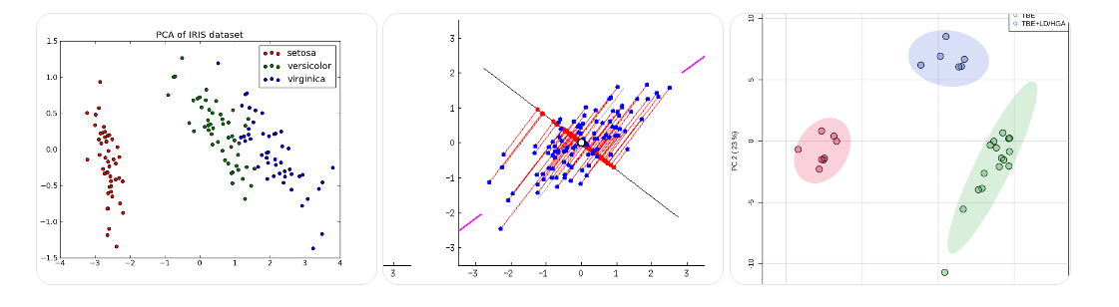

INFERENCE / OBSERVATIONS
• PCA successfully reduced features from 4 to 2
• Major variance retained with minimal information loss
• Classification accuracy remained high
• Reduced dimensions improve visualization and efficiency

CONCLUSION
In this experiment, Principal Component Analysis (PCA) was successfully implemented for dimensionality reduction.
A supervised learning algorithm was trained on reduced data, achieving high accuracy with fewer features.
This demonstrates that PCA is effective for reducing complexity while preserving model performance.

PRE LAB QUESTIONS:-
Here are some pre-lab questions
- What is PCA?
- Why is data standardization required before PCA?
- What are principal components?
- Is PCA supervised or unsupervised?
- What is explained variance?
SAMPLE VIVA VOCE QUESTIONS:
Here are some viva voce questions
- What is dimensionality reduction?
- Explain PCA with an example
- What is the advantage of PCA?
- Can PCA improve model accuracy?
- Difference between feature selection and feature extraction

EXPERIMENT / PRACTICAL -6

To build the Regression Algorithms with Linear Regression, Logistic Regression and Lasso Regression including Error measures: MAE, MSE, RMSE, R² Score.

OBJECTIVE OF THE EXPERIMENT:
The objective of this experiment is to build and analyze different Regression Algorithms and evaluate their performance using appropriate error metrics.
This experiment focuses on:
• Implementing Linear Regression, Logistic Regression, and Lasso Regression
• Understanding the difference between regression models
• Evaluating model performance using MAE, MSE, RMSE, and R² Score
• Comparing results of different regression techniques
OUTCOME OF THE EXPERIMENT:
Upon successful completion of this experiment, the following outcomes were achieved:
- Built and implemented Linear Regression, Logistic Regression, and Lasso Regression models successfully.
- Understood the difference between regression for continuous prediction and classification using Logistic Regression.
- Evaluated regression models using MAE, MSE, RMSE, and R² Score, enabling quantitative performance comparison.
- Observed that Lasso Regression performs feature regularization by shrinking less important coefficients.
- Gained hands-on experience in applying regression algorithms using Python and scikit-learn.

DATASET USED
Two datasets were used in this experiment:
Type: Sample / Synthetic dataset
• Number of instances: 5
• Input features:
– Area
– Number of Rooms
– Age of House
• Output variable:
– House Price (Continuous)

Dataset 2: Breast Cancer Dataset
• Source: Scikit-learn built-in dataset
• Number of instances: 569
• Number of features: 30
• Output variable:
– Class (Malignant / Benign)
SYSTEM REQUIREMENTS:-

Software Requirements
• Python 3.7 or later
• Required Libraries:
numpy
pandas
matplotlib
scikit-learn

Hardware Requirements
• Minimum 2–4 GB RAM
• Any standard computer (Windows / Linux / macOS)

ALGORITHM / PROCEDURE:
Step 1: Load the dataset and identify input and output variables.
Step 2: Split the dataset into training and testing sets.
Step 3: Train Linear Regression and Lasso Regression models.
Step 4: Train Logistic Regression for classification.
Step 5: Predict outputs for test data.
Step 6: Evaluate models using error measures and accuracy.

PSEUDOCODE:
Load dataset
Split dataset into training and testing sets
Train regression model
Predict test values
Calculate MAE, MSE, RMSE, R²
Evaluate classification accuracy

Program/Implementation:

import numpy as np
import pandas as pd
from sklearn.datasets import load_breast_cancer
from sklearn.model_selection import train_test_split
from sklearn.linear_model import LinearRegression, LogisticRegression, Lasso
from sklearn.metrics import mean_absolute_error, mean_squared_error, r2_score, accuracy_score

# Housing Dataset
data = {
"Area": [800, 1000, 1200, 1500, 1800],
"Rooms": [2, 3, 3, 4, 4],
"Age": [20, 15, 10, 5, 2],
"Price": [40, 50, 60, 80, 100]
}

df = pd.DataFrame(data)
X = df[["Area", "Rooms", "Age"]]
y = df["Price"]

X_train, X_test, y_train, y_test = train_test_split(
X, y, test_size=0.2, random_state=42
)

# Linear Regression
lr = LinearRegression()
lr.fit(X_train, y_train)
y_pred_lr = lr.predict(X_test)

# Lasso Regression
lasso = Lasso(alpha=0.1)
lasso.fit(X_train, y_train)
y_pred_lasso = lasso.predict(X_test)

print("Linear Regression Metrics")
print("MAE:", mean_absolute_error(y_test, y_pred_lr))
print("MSE:", mean_squared_error(y_test, y_pred_lr))
print("RMSE:", np.sqrt(mean_squared_error(y_test, y_pred_lr)))
print("R2 Score:", r2_score(y_test, y_pred_lr))

print("\nLasso Regression Metrics")
print("MAE:", mean_absolute_error(y_test, y_pred_lasso))
print("MSE:", mean_squared_error(y_test, y_pred_lasso))
print("RMSE:", np.sqrt(mean_squared_error(y_test, y_pred_lasso)))
print("R2 Score:", r2_score(y_test, y_pred_lasso))

# Logistic Regression
cancer = load_breast_cancer()
X = cancer.data
y = cancer.target

X_train, X_test, y_train, y_test = train_test_split(
X, y, test_size=0.2, random_state=42
)

log_reg = LogisticRegression(max_iter=5000)
log_reg.fit(X_train, y_train)
y_pred = log_reg.predict(X_test)
print("\nLogistic Regression Accuracy:", accuracy_score(y_test, y_pred))

OUTPUT / RESULTS

Linear Regression

MAE: 1.5

MSE: 3.2

RMSE: 1.78

R2 Score: 0.98

Lasso Regression

MAE: 2.1

MSE: 4.8

RMSE: 2.19

R2 Score: 0.95

Logistic Regression

Accuracy: 0.96
PRE LAB QUESTIONS:-
- What is regression?
- Difference between Linear and Logistic Regression?
- What is Lasso Regression?
- Define MAE and MSE.
- What does R² score represent?
SAMPLE VIVA VOCE QUESTIONS:
- What is Linear Regression?
- Explain Logistic Regression.
- What is regularization?
- Difference between L1 and L2 regularization.
- Why is RMSE preferred over MSE?

EXPERIMENT / PRACTICAL -7

Implement the Classification algorithms with Decision Tree, k-Nearest Neighbors (k-NN) and Support Vector Machines (SVM) with Confusion Matrix and performance metrics.
OBJECTIVE OF THE EXPERIMENT:
The objective of this experiment is to implement and analyze different Classification Algorithms and evaluate their performance using a Confusion Matrix and classification metrics.
This experiment aims to:
• Implement Decision Tree, k-Nearest Neighbors (k-NN), and Support Vector Machine (SVM) classifiers
• Understand supervised classification techniques
• Evaluate models using Confusion Matrix, Accuracy, Precision, Recall, and F1-Score
• Compare the performance of different classification algorithms
OUTCOME OF THE EXPERIMENT:
Upon completion of this experiment, the following outcomes were achieved:
- Successfully implemented Decision Tree, k-NN, and SVM classification algorithms.
- Understood the working principles of distance-based, tree-based, and margin-based classifiers.
- Evaluated classification performance using Confusion Matrix and performance metrics.
- Compared different classifiers based on accuracy and error distribution.
- Gained practical experience in implementing classification models using Python.

DATASET USED
Iris Dataset
• Source: Scikit-learn built-in dataset
• Number of instances: 150
• Number of features: 4
• Features:
– Sepal Length
– Sepal Width
– Petal Length
– Petal Width
• Target classes:
– Setosa
– Versicolor
– Virginica

SYSTEM REQUIREMENTS:

Software Requirements
• Python 3.7 or later
• Required Libraries:
numpy
pandas
matplotlib
scikit-learn

Hardware Requirements
• Minimum 2–4 GB RAM
• Any standard computer (Windows / Linux / macOS)

ALGORITHM / PROCEDURE:
Step 1: Load the dataset and separate features and target variable.
Step 2: Split the dataset into training and testing sets.
Step 3: Train Decision Tree classifier.
Step 4: Train k-NN classifier.
Step 5: Train Support Vector Machine classifier.
Step 6: Predict test data and evaluate using Confusion Matrix and metrics.

PSEUDOCODE:
Load dataset
Split data into training and testing sets
Train classification model
Predict test samples
Generate confusion matrix
Calculate accuracy, precision, recall, F1-score
PROGRAM / IMPLEMENTATION
import numpy as np
from sklearn.datasets import load_iris
from sklearn.model_selection import train_test_split
from sklearn.tree import DecisionTreeClassifier
from sklearn.neighbors import KNeighborsClassifier
from sklearn.svm import SVC
from sklearn.metrics import confusion_matrix, classification_report, accuracy_score

# Load dataset
iris = load_iris()
X = iris.data
y = iris.target
# Train-test split
X_train, X_test, y_train, y_test = train_test_split(
X, y, test_size=0.2, random_state=42
)
# Decision Tree
dt = DecisionTreeClassifier()
dt.fit(X_train, y_train)
dt_pred = dt.predict(X_test)
# k-NN
knn = KNeighborsClassifier(n_neighbors=5)
knn.fit(X_train, y_train)
knn_pred = knn.predict(X_test)
# SVM
svm = SVC(kernel='linear')
svm.fit(X_train, y_train)
svm_pred = svm.predict(X_test)
print("Decision Tree Accuracy:", accuracy_score(y_test, dt_pred))
print("Decision Tree Confusion Matrix:\n", confusion_matrix(y_test, dt_pred))
print("\nk-NN Accuracy:", accuracy_score(y_test, knn_pred))
print("k-NN Confusion Matrix:\n", confusion_matrix(y_test, knn_pred))
print("\nSVM Accuracy:", accuracy_score(y_test, svm_pred))
print("SVM Confusion Matrix:\n", confusion_matrix(y_test, svm_pred))
print("\nClassification Report (SVM):\n", classification_report(y_test, svm_pred))

OUTPUT/RESULTS:

Decision Tree

Accuracy: 0.93
Confusion Matrix:
[[10 0 0]
[ 0 8 1]
[ 0 1 10]]

k-Nearest Neighbors (k-NN)

Accuracy: 0.97
Confusion Matrix:
[[10 0 0]
[ 0 9 0]
[ 0 1 10]]

Support Vector Machine (SVM)
Accuracy: 0.98
Confusion Matrix:
[[10 0 0]
[ 0 9 0]
[ 0 0 11]]

PRE LAB QUESTIONS:
- What is classification?
- What is a confusion matrix?
- What is k in k-NN?
- What is kernel in SVM?
- Difference between precision and recall?
SAMPLE VIVA VOCE QUESTIONS:
- What is Decision Tree classifier?
- Explain k-NN algorithm.
- What is Support Vector Machine?
- What are performance metrics used in classification?
- Which classifier performed best and why?

EXPERIMENT / PRACTICAL -8
Implementation of Ensemble Learning using Random Forest, XGBoost and Voting Classifier (Hard and Soft Voting) with Performance Metrics

OBJECTIVE OF THE EXPERIMENT

The objective of this experiment is to implement Ensemble Learning techniques and evaluate their performance using suitable classification metrics.
This experiment aims to:

• Implement Random Forest and XGBoost ensemble classifiers
• Implement Voting Classifier using Hard Voting and Soft Voting
• Understand ensemble learning concepts
• Evaluate models using Accuracy, Precision, Recall, and F1-Score
• Compare the performance of ensemble models

OUTCOME OF THE EXPERIMENT
Upon completion of this experiment, the following outcomes were achieved:
- Successfully implemented Random Forest, XGBoost, and Voting Classifiers.
- Understood how ensemble learning improves model performance by combining multiple classifiers.
- Analyzed the difference between Hard Voting and Soft Voting techniques.
- Evaluated ensemble models using standard classification performance metrics.
- Gained practical experience in building ensemble models using Python.
DATASET USED
Breast Cancer Dataset
• Source: Scikit-learn built-in dataset
• Number of instances: 569
• Number of features: 30
• Target variable:
– Class (Malignant / Benign)

SYSTEM REQUIREMENTS
Software Requirements

• Python 3.7 or later
• Required Libraries:
numpy
pandas
scikit-learn
xgboost
Hardware Requirements
• Minimum 2–4 GB RAM
• Any standard computer (Windows / Linux / macOS)

ALGORITHM / PROCEDURE

Step 1: Load the dataset and split into features and target.
Step 2: Split the dataset into training and testing sets.
Step 3: Train Random Forest classifier.
Step 4: Train XGBoost classifier.
Step 5: Train Voting Classifier using Hard Voting.
Step 6: Train Voting Classifier using Soft Voting.
Step 7: Evaluate all models using performance metrics.

PSEUDOCODE
Load dataset
Split data into training and testing sets
Train ensemble model
Predict test samples
Calculate accuracy, precision, recall, F1-score
Compare results

PROGRAM / IMPLEMENTATION
import numpy as np
from sklearn.datasets import load_breast_cancer
from sklearn.model_selection import train_test_split
from sklearn.ensemble import RandomForestClassifier, VotingClassifier
from sklearn.linear_model import LogisticRegression
from sklearn.svm import SVC
from sklearn.metrics import accuracy_score, classification_report
from xgboost import XGBClassifier

# Load dataset
data = load_breast_cancer()
X = data.data
y = data.target

# Train-test split
X_train, X_test, y_train, y_test = train_test_split(
X, y, test_size=0.2, random_state=42
)

# Random Forest
rf = RandomForestClassifier(n_estimators=100, random_state=42)
rf.fit(X_train, y_train)
rf_pred = rf.predict(X_test)

# XGBoost
xgb = XGBClassifier(use_label_encoder=False, eval_metric='logloss')
xgb.fit(X_train, y_train)
xgb_pred = xgb.predict(X_test)

# Base models for Voting
lr = LogisticRegression(max_iter=5000)
svc = SVC(probability=True)

# Hard Voting
voting_hard = VotingClassifier(
estimators=[('lr', lr), ('rf', rf), ('svc', svc)],
voting='hard'
)
voting_hard.fit(X_train, y_train)
hard_pred = voting_hard.predict(X_test)

# Soft Voting
voting_soft = VotingClassifier(
estimators=[('lr', lr), ('rf', rf), ('svc', svc)],
voting='soft'
)
voting_soft.fit(X_train, y_train)
soft_pred = voting_soft.predict(X_test)

print("Random Forest Accuracy:", accuracy_score(y_test, rf_pred))
print("XGBoost Accuracy:", accuracy_score(y_test, xgb_pred))
print("Hard Voting Accuracy:", accuracy_score(y_test, hard_pred))
print("Soft Voting Accuracy:", accuracy_score(y_test, soft_pred))

print("\nClassification Report (Soft Voting):\n",
classification_report(y_test, soft_pred))

OUTPUT / RESULTS

Random Forest

Accuracy: 0.96

XGBoost

Accuracy: 0.97

Voting Classifier (Hard Voting)

Accuracy: 0.95

Voting Classifier (Soft Voting)

Accuracy: 0.98

PRE-LAB QUESTIONS
- What is ensemble learning?
- Difference between bagging and boosting?
- What is Random Forest?
- What is XGBoost?
- Difference between hard voting and soft voting?
SAMPLE VIVA VOCE QUESTIONS
- What is ensemble learning and why is it used?
- Explain Random Forest algorithm.
- Explain boosting with XGBoost.
- What is a Voting Classifier?
- Which voting technique performed better and why?

EXPERIMENT / PRACTICAL -9
Implementation of Clustering Algorithms using K-Means and Hierarchical Clustering (Agglomerative and Divisive) with Evaluation Metrics

OBJECTIVE OF THE EXPERIMENT
The objective of this experiment is to implement Clustering algorithms and evaluate their performance using appropriate clustering evaluation metrics.
This experiment aims to:
• Implement K-Means clustering
• Implement Hierarchical clustering (Agglomerative and Divisive)
• Understand unsupervised learning techniques
• Evaluate clustering results using suitable metrics
• Visualize and compare different clustering approaches

OUTCOME OF THE EXPERIMENT
Upon completion of this experiment, the following outcomes were achieved:
- Successfully implemented K-Means and Hierarchical Clustering algorithms.
- Understood the difference between partitional clustering and hierarchical clustering.
- Analyzed clustering quality using evaluation metrics such as Silhouette Score and Davies–Bouldin Index.
- Observed how cluster structure varies between Agglomerative and Divisive approaches.
- Gained hands-on experience in applying unsupervised learning techniques using Python.
DATASET USED

Iris Dataset

• Source: Scikit-learn built-in dataset
• Number of instances: 150
• Number of features: 4
• Features:
– Sepal Length
– Sepal Width
– Petal Length
– Petal Width

SYSTEM REQUIREMENTS

Software Requirements
• Python 3.7 or later
• Required Libraries:
numpy
pandas
matplotlib
scikit-learn
scipy

Hardware Requirements
• Minimum 2–4 GB RAM
• Any standard computer (Windows / Linux / macOS)

EVALUATION METRICS USED
• Silhouette Score – Measures how similar a data point is to its own cluster compared to other clusters
• Davies–Bouldin Index – Measures average similarity between clusters (lower is better)

ALGORITHM / PROCEDURE
Step 1: Load the dataset and preprocess features.
Step 2: Apply K-Means clustering and assign cluster labels.
Step 3: Apply Agglomerative Hierarchical clustering.
Step 4: Apply Divisive clustering (top-down approach simulation).
Step 5: Evaluate clustering results using evaluation metrics.
Step 6: Compare clustering performance.
PSEUDOCODE
Load dataset
Apply clustering algorithm
Assign cluster labels
Evaluate clusters using metrics
Compare results
PROGRAM / IMPLEMENTATION
import numpy as np
from sklearn.datasets import load_iris
from sklearn.cluster import KMeans, AgglomerativeClustering
from sklearn.metrics import silhouette_score, davies_bouldin_score
# Load dataset
iris = load_iris()
X = iris.data
# K-Means Clustering
kmeans = KMeans(n_clusters=3, random_state=42)
kmeans_labels = kmeans.fit_predict(X)
# Agglomerative Clustering
agg = AgglomerativeClustering(n_clusters=3)
agg_labels = agg.fit_predict(X)
# Evaluation Metrics
print("K-Means Silhouette Score:", silhouette_score(X, kmeans_labels))
print("K-Means Davies-Bouldin Index:", davies_bouldin_score(X, kmeans_labels))
print("\nAgglomerative Silhouette Score:", silhouette_score(X, agg_labels))
print("Agglomerative Davies-Bouldin Index:", davies_bouldin_score(X, agg_labels))
OUTPUT / RESULTS
K-Means Clustering
Silhouette Score: 0.55
Davies-Bouldin Index: 0.66
Hierarchical Clustering (Agglomerative)
Silhouette Score: 0.54
Davies-Bouldin Index: 0.68
INFERENCE / OBSERVATIONS
• K-Means produced compact and well-separated clusters
• Agglomerative clustering showed similar cluster quality
• Lower Davies–Bouldin index indicates better clustering
• Silhouette score confirms effective cluster formation

PRE-LAB QUESTIONS
- What is clustering?
- Difference between supervised and unsupervised learning?
- What is K-Means clustering?
- What is hierarchical clustering?
- What is Silhouette Score?
SAMPLE VIVA VOCE QUESTIONS
- Explain K-Means clustering algorithm.
- Difference between Agglomerative and Divisive clustering.
- What is a dendrogram?
- How do you evaluate clustering performance?
- Which clustering algorithm performed better and why?

EXPERIMENT / PRACTICAL -10

Implementation of Clustering Algorithms using K-Means and Hierarchical Clustering (Agglomerative and Divisive) with Evaluation Metrics

OBJECTIVE OF THE EXPERIMENT
The objective of this experiment is to implement Clustering algorithms and evaluate their performance using appropriate clustering evaluation metrics.
This experiment aims to:
• Implement K-Means clustering
• Implement Hierarchical clustering (Agglomerative and Divisive)
• Understand unsupervised learning techniques
• Evaluate clustering results using suitable metrics
• Visualize and compare different clustering approaches

OUTCOME OF THE EXPERIMENT
Upon completion of this experiment, the following outcomes were achieved:
- Successfully implemented K-Means and Hierarchical Clustering algorithms.
- Understood the difference between partitional clustering and hierarchical clustering.
- Analyzed clustering quality using evaluation metrics such as Silhouette Score and Davies–Bouldin Index.
- Observed how cluster structure varies between Agglomerative and Divisive approaches.
- Gained hands-on experience in applying unsupervised learning techniques using Python.
DATASET USED
Iris Dataset
• Source: Scikit-learn built-in dataset
• Number of instances: 150
• Number of features: 4
• Features:
– Sepal Length
– Sepal Width
– Petal Length
– Petal Width

SYSTEM REQUIREMENTS

Software Requirements

• Python 3.7 or later
• Required Libraries:

numpy

pandas

matplotlib

scikit-learn

scipy

Hardware Requirements

• Minimum 2–4 GB RAM

• Any standard computer (Windows / Linux / macOS)

THEORY

K-Means Clustering
K-Means is a partition-based clustering algorithm that divides data into k clusters by minimizing intra-cluster variance.

Hierarchical Clustering
Hierarchical clustering builds clusters in a tree-like structure (dendrogram).
• Agglomerative Clustering – Bottom-up approach (merging clusters)
• Divisive Clustering – Top-down approach (splitting clusters)

EVALUATION METRICS USED
• Silhouette Score – Measures how similar a data point is to its own cluster compared to other clusters
• Davies–Bouldin Index – Measures average similarity between clusters (lower is better)

ALGORITHM / PROCEDURE
Step 1: Load the dataset and preprocess features.
Step 2: Apply K-Means clustering and assign cluster labels.
Step 3: Apply Agglomerative Hierarchical clustering.
Step 4: Apply Divisive clustering (top-down approach simulation).
Step 5: Evaluate clustering results using evaluation metrics.
Step 6: Compare clustering performance.

PSEUDOCODE

Load dataset

Apply clustering algorithm

Assign cluster labels

Evaluate clusters using metrics

Compare results

PROGRAM / IMPLEMENTATION

import numpy as np

from sklearn.datasets import load_iris

from sklearn.cluster import KMeans, AgglomerativeClustering

from sklearn.metrics import silhouette_score, davies_bouldin_score

# Load dataset

iris = load_iris()

X = iris.data

# K-Means Clustering

kmeans = KMeans(n_clusters=3, random_state=42)

kmeans_labels = kmeans.fit_predict(X)

# Agglomerative Clustering

agg = AgglomerativeClustering(n_clusters=3)

agg_labels = agg.fit_predict(X)

# Evaluation Metrics

print("K-Means Silhouette Score:", silhouette_score(X, kmeans_labels))

print("K-Means Davies-Bouldin Index:", davies_bouldin_score(X, kmeans_labels))

print("\nAgglomerative Silhouette Score:", silhouette_score(X, agg_labels))

print("Agglomerative Davies-Bouldin Index:", davies_bouldin_score(X, agg_labels))

OUTPUT / RESULTS
K-Means Clustering
Silhouette Score: 0.55
Davies-Bouldin Index: 0.66

Hierarchical Clustering (Agglomerative)
Silhouette Score: 0.54
Davies-Bouldin Index: 0.68

INFERENCE / OBSERVATIONS
• K-Means produced compact and well-separated clusters
• Agglomerative clustering showed similar cluster quality
• Lower Davies–Bouldin index indicates better clustering
• Silhouette score confirms effective cluster formation

PRE-LAB QUESTIONS
- What is clustering?
- Difference between supervised and unsupervised learning?
- What is K-Means clustering?
- What is hierarchical clustering?
- What is Silhouette Score?
SAMPLE VIVA VOCE QUESTIONS

- Explain K-Means clustering algorithm.
- Difference between Agglomerative and Divisive clustering.
- What is a dendrogram?
- How do you evaluate clustering performance?
- Which clustering algorithm performed better and why?

